+8 

6735 Conroy Road, Suite 104 6900 Turkey Lake Rd, Suite 1-5
Orlando, FL 32835 Orlando, FL 32819

Non Member Pricing Groupon Voucher No_____________________
____________________________________
____________________________________
____________________________________
Member Pricing APPOINTMENT DATE _________
____________________________________
____________________________________
____________________________________ Products: _______________________________
Appointment Date:
Personal Information:

Name: _________________________________________________________________________ Today’s Date: _________________________ (First Name) (Last Name)
Birth Date: _____/_____/_____ Age: _______ E-mail: _________________________________________________________________ (Month) (Day) (Year)
Home Phone: ( ) _____________________________ Cell Phone: ( ) __________________________________________
Home Address: ____________________________________________________________________________________________________
City: ________________________________________ State: _________________________________ Zip: _________________________
Occupation: __________________________________________ Business Phone: ( ) ____________________________________
In case of emergency, please contact:
Name: ____________________________________________________________________________________________________________
Phone: ( ) ________________________________________ Cell Phone: ( ) _____________________________________
May we share your medical information with this person? Yes No
Please list anyone else we can share your medical information with: ____________________________________________________________________________________________________________________________________________________________________________________________________________________________________________
Where did you hear about Sanctuary Salon & Med Spa?
Friend or Family Member, Name: ________________________________________________________________________________

Advertisement Internet Local Event Other ______________________________________________________

How do you preferred to be contacted? Phone E-Mail Text Message (1)


More information about yourself:
Have you ever had laser treatments or Electrolysis? Yes No
Procedures/Areas treated: _________________________________________________________________________________________
Number of Treatments: _______________________________ Name of Spa where treatment done ___________________
Any complications? ________________________________________________________________________________________________
Please Circle The Areas You Need Treated On The Diagram Below:
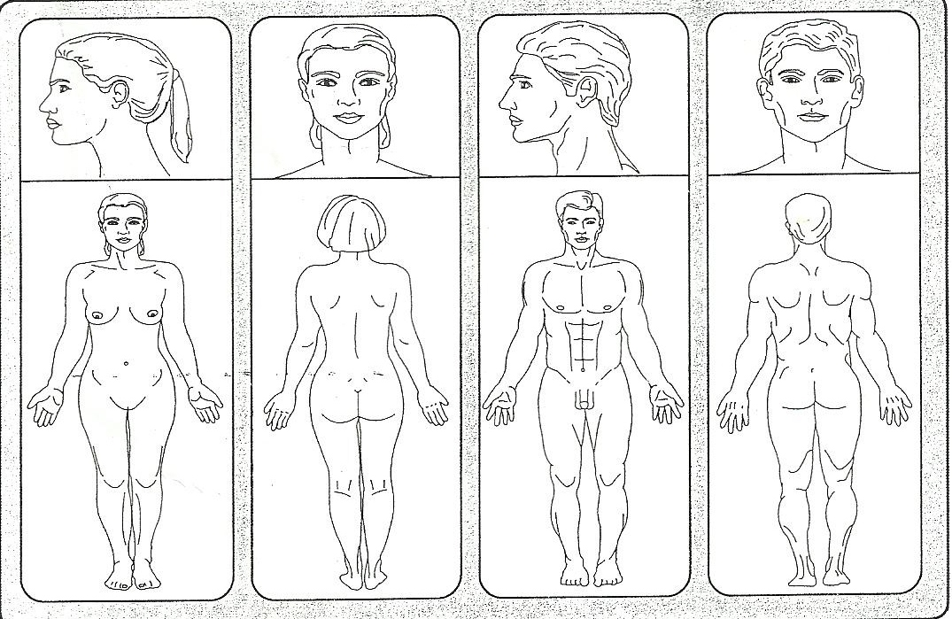
Patient Name: |  |  | Race/Ethnicity:
Skin Type: | Fair__________ | Olive________ | Black__________ | Dark(Hispanic)______ | Other_______
Hair Color: | Black________ | Blonde______ | Gray__________ | Brown_________ | Red________

(2)

- What is the natural color of your eyes? II. What happens if you stay in the sun too long?
- Light blue, gray, green 0. Painful redness, blistering and peeling
- Blue, gray, green 1. Blistering followed by peeling
- Blue 2. Burn sometimes followed by peeling
- Dark brown 3. Rarely burns
- Brownish black 4. Never burns

What is the natural color of your hair? To what degree do you turn brown? 0. Sandy/Red 0. Hardly or not at all 1. Blond 1. Light color tan 2. Chestnut/Dark Blond 2. Reasonable tan 3. Dark Brown 3. Tan very easy 4. Black 4. Turn dark brown quickly
What is the color of your skin Do you turn brown within several hours after (In non-sun-exposed areas) sun exposure? 0. Reddish 0. Never 1. Very Pale 1. Seldom 2. Pale with beige tint 2. Sometimes 3. Light Brown 3. Often 4. Dark Brown 4. Always

Do you have freckles? How does you face react to the sun? 0. Many 0. Very Sensitive 1. Several 1. Sensitive 2. Few 2. Normal 3. Incidental 3. Very Resistant 4. None 4. Never had a problem
Score: ___________ Score: ___________
Skin Type Score | Fitzpatrick Skin Type
0-7 | I
8-16 | II
17-25 | III
25-30 | IV
30+ | V-VI
- When did you last expose your body to the sun?
- More than 3 months ago
- 2-3 months ago
- 1-2 months ago
- Less than a month ago
- Less than 2 weeks ago
Did you expose the area(s) you wish to have to the sun? 0. Never 1. Hardly Ever 2. Sometimes 3. Often 4. Always Score: ___________ (3)

MEDICAL HISTORY:
How would you describe your general health Good Fair Poor
Have you had a major illness or been hospitalized within the last 5 years? Yes No
Please describe: _______________________________________________________________________________________________________
Are you currently using any medications? (Topical, Ingestible or injectable) Yes No
Medications | Condition

Do you have acne? Yes No Are you taking Accutane? Yes No
Have you taken Accutane in the last 6 months? Yes No Are you using Rogaine, Propeci, Minoxidil? Yes No
Are you using steroids? Yes No Are you allergic to latex? Yes No
Do you have any tattoos and/or permanent makeup? Yes No if yes where? _____________________________________
Are you taking any herbal or vitamin supplements? Yes No
Do you use tobacco? Yes No Do you consume more than two alcoholic beverages per day? Yes No

Have you ever had any of the following?

Skin Cancer or Pre-Cancer Yes No
What type: Basal Cell Dysplastic Nevus Squamous Cell Melanoma
If yes, when: ____________________________________________________ Where on the body: __________________________________
Was it treat and how? _________________________________________________________________________________________________
Have you ever had any surgical procedure? Yes No
Please Describe: ___________________________________________________________________________________________________
(4)
Have you ever had any of the following?
Heart Disease or Condition HIV or AIDS Liver Disease/Hepatitis (A, B, or C) Keloid Scarring Methemoglobinemia Vasculitis with/without skin involvement Abnormal Blood Pressure (High or Low) Connective Tissue Disorders Epilepsy/Seizures /Lupus Tattoo or Permanent Makeup Allergy to Lidocaine or other “caines” Bleeding Disorders Pacemaker or Palpitations Oral Herpes or Cold Sores Breast Feeding Currently Genital Herpes

Venereal Disease Implant (breast, metal) PCOS Diabetes Hormone/Thyroid Disorder Respiratory Condition Anemia Ulcers Transplants Psychiatric Disorder Eczema Eye Disease Psoriasis Sinus or Ear Trouble Skin Condition/MRSA/Infection Cancer
Please describe or explain any of the above:
________________________________________________________________________________________________________________________________________________________________________________________________________________________________________________
Have you ever had any of the following treatments in the last 3 months:
Chemical Peel Laser Peel BOTOX Fillers Glycolic Peel Microdermabrasion
Cosmetic Surgery Other: __________________________________________________________________________________
What skin care products are you using? (Cleanser, Moisturizer, ect.) _______________________________________________________________________________________________________________________
Do you use or have you ever used any of the following products? Retin A AHA Hydroquinone Other:________________________________________________________ Any reactions? __________________________________________
Is there any other information about your health that we should know? ________________________________________________________________________________________________________________________________________________________________________________________________________________________________________________
Women Only: Are you pregnant? Yes No Expected Delivery Date: ________/_________/_____________
? Yes No ? Yes No ? Yes No
Are you trying to become pregnant? Yes No Are you currently nursing? Yes No
? Yes No ? Yes No ? Yes No
? Yes No ? Yes No ? Yes No
? Yes No ? Yes No ? Yes No
? Yes No ? Yes No ? Yes No
Are you taking contraceptives? Yes No Menstrual cycles regular? Yes No
? Yes No ? Yes No ? Yes No
? Yes No ? Yes No ? Yes No
? Yes No ? Yes No ? Yes No
? Yes No ? Yes No ? Yes No
(5)
Terms & Conditions
Please initial
_____You will be rebooked after the first treatment every 6-8 weeks.

_____We will confirm via email 2 days prior to your appointment. Please make sure
YOU DO NOT OPT OUT OF EMAIL!

_____We require 24 hour notice for appointment cancellation or you will forfeit that visit. Please note: All cancellations must be in writing, either by email or text through our automated reminder system. No Phone calls. No Exceptions.

____ As discussed in your consultation, if you have had sun exposure, self tanned or on antibiotics prior to your treatment we reserve the right to refuse treatment and you will forfeit that visit and it will be deducted from your package series. NO EXCEPTIONS.

_____Area of treatment must be shaved the night before treatment is scheduled. All treated areas are to be shaved with a new blade and must be done the night before treatment. If not there will be an additional charge based on the area size.

_____All treatments are for the same area

_____Treatments must be completed in 1 year from date of purchase. If treatments are not completed in 1 year you will forfeit any remaining treatments.

_____Tipping your technician at the time of each service is much appreciated.
Small area $8-$10 Medium area $12-$15 Large area $20-$25

_____ If you are receiving laser in an area that has a tattoo, please be aware that the laser technician will stop within
one inch of the area that has tattoo. Leaving the area surrounding the tattoo not treated with the laser.

_____ Touch up pricing is only available once you have already completed a minimum of 12 laser treatments with Sanctuary Laser Spa

_____There are NO REFUNDS. NO EXCEPTIONS.

_____ Laser Treatments are non-transferable to any other person.

_____ Laser packages cannot be changed/ switched or altered to any other area/s. Client must complete treatment on area/s purchased.

_____ If you refer a new laser client you will receive 1 free treatment for 1 small area.

_____Absolutely no children are allowed in the treatment room during service being done
No EXCEPTIONS! Children under the age of 12 are not allowed in waiting area
without adult supervision. If children are brought without adult supervision you
will be required to reschedule your appointment and you will lose automatically
that day’s treatment from your treatment series package.

_____ Sanctuary Salon & Med Spa reserves the right to change the terms and conditions of this contract as needed without prior notice.

______THESE TERMS AND CONDITIONS WILL BE APPLICABLE FOR ALL FURTUE LASER PURCHASES WITH SANCTUARY SALON & MED SPA.

TIPS CAN BE PLACED ON A CREDIT CARD OR BE PAID IN CASH.
PLEASE NOTE ALL GROUPON CLIENTS: We will only accept Groupons ONE TIME ONLY, per person for new clients only. Additional laser services can be purchased directly through Sanctuary.
CLIENTS MUST BE AT LEAST 16 YEAR OF AGE TO RECEIVE LASER TREATMENTS AND MUST BE ACCOMPANIED BY AN ADULT FOR ALL TREATMENTS.
PLEASE BE ADVISED: WE ARE UNABLE TO EVALUATE HOW MANY TREATMENTS A CLIENT MAY NEED.
**FOR THOSE CLIENTS WHO HAVE BLONDE, WHITE OR GRAY HAIR WE DO OFFER ELECTROLYSIS SERVICES** (6)

Laser Hair Removal Consent Form
I,______________________, hereby authorize Sanctuary Salon & Med Spa laser hair on me. The laser targets pigment in the hair follicle to treat unwanted pigmented hair for long‐term hair reduction. Hair grows in cycles. The laser works during the anagen or “growing phase” of hair growth. Therefore, multiple treatments are needed at regular spaced intervals to treat all of the hair in a treatment area for significant reduction of hair growth. For maximum results, it is necessary to follow the recommended treatment schedule.
I have read, agree to and understand the following points: Initial_____
____• Laser therapy is not recommended if any of the following conditions exist: Pregnant or Nursing Female, Photosensitivity disorder, Immunosuppressive disease, Diabetes, Bleeding Disorder, Seizure disorder triggered by light, active Herpes (cold sores), active Shingles or any active infection. I have notified my treating clinician if I have one or more of the conditions above.
____• All treated areas are to be shaved with a new blade and MUST be done the night before treatment. Shaving the area is required to ensure proper treatment results. In addition, treating an area unshaved can be more sensitive and cause discomfort. If you are unable to shave the area you must inform upon making your appointment in order to allow for sufficient time for treatments. If you show up for your treatment and have not shaved, we reserve the right to refuse treatment due to time constraints and your treatment will be deducted from your laser package. However, if you show up for your treatment unshaved and time permits, the technician will shave the area but at an additional charge which must be paid prior to any treatments. Cost will be dependent upon size of area. See chart.
____• I understand that treatment is not recommended for tanned patients until the tan has faded and that sun exposure must be avoided between treatments. I have not tanned, and will not tan, in the areas to be treated during the entire treatment course and for six weeks before and after treatment. This includes sun exposure and tanning booths. Artificial tanning products must be discontinued two weeks prior to treatments.
____• Test spots may be done to evaluate skin response prior to FULL treatment.
____• Photographs of the treatment are may be taken for my chart and future comparison. Complete confidentiality will be maintained.
____• Most clients will need minimum of 10-12 sessions. The total number of treatment sessions may vary among individuals. On rare occasion there may be a client that does not respond to treatment.
____• Both pre and post treatment instructions has been given to me and I understand them completely. I accept responsibility in complying with the treatment care instructions provided.
____• The treatment cost has been discussed with me.
_____ As discussed in your consultation, if you have had sun exposure, self tanned or on antibiotics prior to your treatment we reserve the right to refuse treatment and you will forfeit that visit and it will be deducted from your package series. NO EXCEPTIONS.

I am aware of the following possible risks/complications with laser treatments.
____• Discomfort- Some mild discomfort may be experienced during laser treatments. Numbing cream is recommend to control any discomfort and should be applied 30 minutes prior to your scheduled treatment time. You may purchase numbing cream from Sanctuary Salon & Med Spa and the Laser Spa.
____• Infection‐ Skin infection is a possibility although rare, whenever a skin procedure is performed. Herpes simplex virus infections (cold sores) around the mouth can occur following a treatment. This applies to individuals with a past history of herpes simplex virus infections. Antiviral medication is recommended during the treatment and is available by prescription. Should any type of skin infection occur, additional treatments or medical antibiotics may be necessary.
_____• Short term effects may include reddening, swelling, bumps, mild burning, temporary bruising or blistering. Hyper-pigmentation (browning of skin) and Hypo-pigmentation (lightening of skin), although rare, may occur. These conditions usually resolve within 3 – 6 months, but permanent color change is a rare risk, less than 1%. Avoiding sun exposure before and after treatment reduces the risk of color change.
_____• Scarring‐ However slight, there is a risk of scarring and skin textural changes. It is important that you follow all post treatment instructions carefully. Compliance is crucial for healing and prevention of scarring.
- Sometimes your skin can be prone to histamine reactions, if this occurs you may need to take an anti-histamine medication or apply a
Hydrocortisone cream or aloe to soothe the area.
- Clients should always call if there are any questions or concerns regarding any of the above.
ACKNOWLEDGEMENT:
My questions regarding the Laser Hair Removal procedures have been answered satisfactorily. I understand the procedure and accept the risks. I hereby release Sanctuary Salon & Med Spa and Dr. Merchant from all liabilities associated with the above indicated procedure.

_______________________
Print Name
________________________
Patient signature Date
(7)

PLEASE NEXT PAGES ARE YOUR PRE AND POST INSTRUCTIONS.
PLEASE TAKE HOME AND READ.
THANK YOU.



Pre-Treatment Instructions for Laser Hair Removal
- Avoid Sun Exposure:
  - Stay out of the sun, tanning beds, and self-tanning products for at least 2 weeks prior to your session to reduce the risk of skin irritation and ensure optimal results.
- No Waxing or Plucking:
  - Do not wax, pluck, or use hair removal creams 4 weeks before your treatment, as these methods remove the hair root, which the laser targets. Shaving is permitted.
- Shave the Treatment Area:
  - Please shave the area to be treated 24 hours before your appointment. If you arrive unshaven, we reserve the right to refuse treatment due to time constraints, and the session may be deducted from your package.
- Avoid Skincare Products:
  - Do not apply lotions, deodorants, or any other products to the treatment area on the day of your session.
- Stay Hydrated:
  - Drink plenty of water to keep your skin hydrated, which may improve treatment outcomes.
- Topical Medications & Skincare:
  - Discontinue use of self-tanning products and Retin-A 1 week before your session. Avoid using topical medications or other skincare products on the treatment area for 3-5 days prior to treatment.
  - If you are on antibiotics, wait 4 weeks after your last dose before scheduling laser hair removal.
- Appointment Timeliness:
  - Arrive on time. We may reschedule your appointment if you are late or have not complied with the pre-treatment instructions.
- Childcare:
  - Please arrange for childcare, as children are not permitted in the treatment room or waiting area during your appointment.

Numbing Cream Instructions
To ensure a comfortable experience, we may recommend a numbing cream which you can purchase :
- Follow Our Instructions: Only apply the cream to the specific areas we have instructed.
- Timing: Apply the cream 20 minutes before your appointment time.
- Usage: Use as directed for safe and effective application.

Post-Treatment Instructions for Laser Hair Removal
- Avoid Sun Exposure:
  - Protect the area treated from sun exposure for at least 2 weeks after your session. Use a broad-spectrum sunscreen with SPF 30 or higher.
- Cool Compresses:
  - Apply cool compresses to soothe any redness, swelling, or discomfort.
- Avoid Heat and Hot Water:
  - Skip hot showers, saunas, and other heat sources for 24-48 hours to prevent skin irritation.
- No Makeup or Deodorant:
  - Avoid applying makeup or deodorant to the treated area for at least 24 hours post-treatment, especially if the skin is sensitive.
- Stick to Your Treatment Schedule:
  - Consistency is key to achieving the best, long-lasting results.
- Skin Care for Irritation:
  - If you experience broken skin or blisters, apply an antibiotic ointment and notify us immediately.
  - Use 1% hydrocortisone cream twice daily for 3-5 days if needed for redness or irritation.
  - Cold packs, aloe vera, or other cooling preparations can be used to ease temporary discomfort.

These instructions will help ensure the best possible outcomes for your laser hair removal treatments. Please reach out if you have any questions or concerns before or after your sessions!

Sanctuary Laser Spa Sanctuary Salon & Med Spa
Merchant pediatrics
6900 Turkey Lake Road, Suite 1-5 6735 Conroy Road, Suite 104
Orlando, Florida 32819 Orlando, Florida 32835
Call or text 407-909-1011 407-909-1011
www.sanctuarysalondayspa.com (10)

