Date: _________________

Personal Information:

Name: _________________________________________________________________________ Today’s Date: _________________________ (First Name) (Last Name)
Birth Date: _____/_____/_____ Age: _______ E-mail: _________________________________________________________________ (Month) (Day) (Year)
Home Phone: ( ) _____________________________ Cell Phone: ( ) __________________________________________
Home Address: ____________________________________________________________________________________________________
City: ________________________________________ State: _________________________________ Zip: _________________________
Occupation: __________________________________________ Business Phone: ( ) ____________________________________

In case of emergency, please contact:

Name: ____________________________________________________________________________________________________________
Phone: ( ) ________________________________________ Cell Phone: ( ) _____________________________________
May we share your medical information with this person? Yes No
Please list anyone else we can share your medical information with: ____________________________________________________________________________________________________________________________________________________________________________________________________________________________________________
Where did you hear about Sanctuary Salon & Med Spa?

Friend or Family Member, Name: ________________________________________________________________________________

Advertisement Internet Local Event Other ______________________________________________________

How do you preferred to be contacted? Phone E-Mail Text Message (1)

More information about yourself:
Have you ever had laser treatments or Electrolysis? Yes No
Procedures/Areas treated: _________________________________________________________________________________________
Any complications? ________________________________________________________________________________________________
Please Circle The Areas You Need Treated On The Diagram Below:
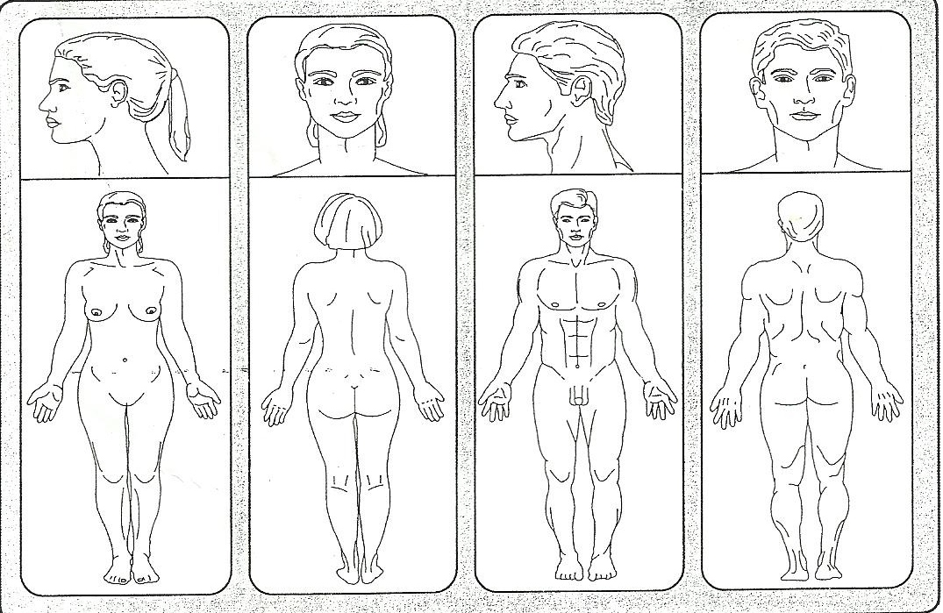
Patient Name: |  |  | Race/Ethnicity:
Skin Type: | Fair__________ | Olive________ | Black__________ | Dark(Hispanic)______ | Other_______
Hair Color: | Black________ | Blonde______ | Gray__________ | Brown_________ | Red________

- What is the natural color of your eyes? II. What happens if you stay in the sun too long?
- Light blue, gray, green 0. Painful redness, blistering and peeling
- Blue, gray, green 1. Blistering followed by peeling
- Blue 2. Burn sometimes followed by peeling
- Dark brown 3. Rarely burns
- Brownish black 4. Never burns

What is the natural color of your hair? To what degree do you turn brown? 0. Sandy/Red 0. Hardly or not at all 1. Blond 1. Light color tan 2. Chestnut/Dark Blond 2. Reasonable tan 3. Dark Brown 3. Tan very easy 4. Black 4. Turn dark brown quickly
What is the color of your skin Do you turn brown within several hours after (In non-sun-exposed areas) sun exposure? 0. Reddish 0. Never 1. Very Pale 1. Seldom 2. Pale with beige tint 2. Sometimes 3. Light Brown 3. Often 4. Dark Brown 4. Always

Do you have freckles? How does you face react to the sun? 0. Many 0. Very Sensitive 1. Several 1. Sensitive 2. Few 2. Normal 3. Incidental 3. Very Resistant 4. None 4. Never had a problem
Score: ___________ Score: ___________
Skin Type Score | Fitzpatrick Skin Type
0-7 | I
8-16 | II
17-25 | III
25-30 | IV
30+ | V-VI
- When did you last expose your body to the sun?
- More than 3 months ago
- 2-3 months ago
- 1-2 months ago
- Less than a month ago
- Less than 2 weeks ago
Did you expose the area(s) you wish to have to the sun? 0. Never 1. Hardly Ever 2. Sometimes 3. Often 4. Always Score: ___________ (3)

MEDICAL HISTORY:
How would you describe your general health Good Fair Poor
Have you had a major illness or been hospitalized within the last 5 years? Yes No
Please describe: _______________________________________________________________________________________________________
Are you currently using any medications? (Topical, Ingestible or injectable) Yes No
Medications | Condition

Do you have acne? Yes No Are you taking Accutane? Yes No
Have you taken Accutane in the last 6 months? Yes No Are you using Rogaine, Propeci, Minoxidil? Yes No
Are you using steroids? Yes No Are you allergic to latex? Yes No
Do you have any tattoss and/or permanent makeup? Yes No if yes where? _____________________________________
Are you taking any herbal or vitamin supplements? Yes No
Do you use tobacco? Yes No Do you consume more than two alcoholic beverages per day? Yes No

Have you ever had any of the following?

Skin Cancer or Pre-Cancer Yes No
What type: Basal Cell Dysplastic Nevus Squamous Cell Melanoma
If yes, when: ____________________________________________________ Where on the body: __________________________________
Was it treat and how? _________________________________________________________________________________________________
Have you ever had any surgical procedure? Yes No
Please Describe: ___________________________________________________________________________________________________
(4)
Have you ever had any of the following?
Heart Disease or Condition HIV or AIDS Liver Disease/Hepatitis (A, B, or C) Keloid Scarring Methemoglobinemia Vasculitis with/without skin involvement Abnormal Blood Pressure (High or Low) Connective Tissue Disorders Epilepsy/Seizures /Lupus Tattoo or Permanent Makeup Allergy to Lidocaine or other “caines” Bleeding Disorders Pacemaker or Palpitations Oral Herpes or Cold Sores Breast Feeding Currently Genital Herpes

Venereal Disease Implant (breast, metal) PCOS Diabetes Hormone/Thyroid Disorder Respiratory Condition Anemia Ulcers Transplants Psychiatric Disorder Eczema Eye Disease Psoriasis Sinus or Ear Trouble Skin Condition/MRSA/Infection Cancer
Please describe or explain any of the above:
________________________________________________________________________________________________________________________________________________________________________________________________________________________________________________
Have you ever had any of the following treatments in the last 3 months:
Chemical Peel Laser Peel BOTOX Fillers Glycolic Peel Microdermabrasion
Cosmetic Surgery Other: __________________________________________________________________________________
What skin care products are you using? (Cleanser, Moisturizer, ect.) _______________________________________________________________________________________________________________________
Do you use or have you ever used any of the following products? Retin A AHA Hydroquinone Other:________________________________________________________ Any reactions? __________________________________________
Is there any other information about your health that we should know? ________________________________________________________________________________________________________________________________________________________________________________________________________________________________________________
Women Only: Are you pregnant? Yes No Expected Delivery Date: ________/_________/_____________
? Yes No ? Yes No ? Yes No
Are you trying to become pregnant? Yes No Are you currently nursing? Yes No
? Yes No ? Yes No ? Yes No
? Yes No ? Yes No ? Yes No
? Yes No ? Yes No ? Yes No
? Yes No ? Yes No ? Yes No
Are you taking contraceptives? Yes No Menstrual cycles regular? Yes No
? Yes No ? Yes No ? Yes No
? Yes No ? Yes No ? Yes No
? Yes No ? Yes No ? Yes No
? Yes No ? Yes No ? Yes No
(5)

Terms & Conditions
Please initial
_____You will be rebooked after the first treatment every 6-8 weeks.

_____We will confirm via email 2 days prior to your appointment. Please make sure
YOU DO NOT OPT OUT OF EMAIL!

_____We require 24 hour notice for appointment cancellation or you will forfeit that visit.

_____Area of treatment should be shaved prior to appointment. All treated areas are to be shaved with a new blade and must be done the night before treatment. If not an additional $10 per area will be charged.

_____All treatments are for the same area

_____Treatments must be completed in 1 year from date of purchase.

_____Tipping your technician at the time of each service is much appreciated.
Small area $8-$10 Medium area $12-$15 Large area $20-$25

_____There are no refunds. No Exceptions

_____ Laser Treatments are non-transferable to any other person.

_____ If you refer a new laser client you will receive 1 free treatment for 1 small area.

_____Absolutely no children are allowed in the treatment room during service being done
No EXCEPTIONS! Please make arrangement for your children.

TIPS CAN BE PLACED ON A CREDIT CARD OR BE PAID IN CASH.

PLEASE NOTE ALL GROUPON CLIENTS: We will only accept Groupons one time only, per person for new clients only. Additional laser services can be purchased directly through Sanctuary.
CLIENTS MUST BE AT LEAST 16 YEAR OF AGE TO RECEIVE LASER TREATMENTS
PLEASE BE ADVISED: WE ARE UNABLE TO EVALUATE HOW MANY TREATMENTS A CLIENT MAY NEED.
**FOR THOSE CLIENTS WHO HAVE BLONDE, WHITE OR GRAY HAIR WE DO OFFER ELECTROLYSIS SERVICES**

(6)

Laser Hair Removal Consent Form
I,______________________, hereby authorize Sanctuary Salon & Med Spa laser hair on me. The laser targets pigment in the hair follicle to treat unwanted pigmented hair for long‐term hair reduction. Hair grows in cycles. The laser works during the anagen or “growing phase” of hair growth. Therefore, multiple treatments are needed at regular spaced intervals to treat all of the hair in a treatment area for significant reduction of hair growth. For maximum results, it is necessary to follow the recommended treatment schedule.
I have read, agree to and understand the following points: Initial_____
____• Laser therapy is not recommended if any of the following conditions exist: Pregnant or Nursing Female, Photosensitivity disorder, Immunosuppressive disease, Diabetes, Bleeding Disorder, Seizure disorder triggered by light, active Herpes (cold sores), active Shingles or any active infection. I have notified my treating clinician if I have one or more of the conditions above.
____• I understand that treatment is not recommended for tanned patients until the tan has faded and that sun exposure must be avoided between treatments. I have not tanned, and will not tan, in the areas to be treated during the entire treatment course and for six weeks before and after treatment. This includes sun exposure and tanning booths. Artificial tanning products must be discontinued two weeks prior to treatments.
____• Test spots may be done to evaluate skin response prior to FULL treatment.
____• Photographs of the treatment are may be taken for my chart and future comparison. Complete confidentiality will be maintained.
____• Most clients will need minimum of 6-8 sessions. The total number of treatment sessions may vary among individuals. On rare occasion there may be a client that does not respond to treatment.
____• Both pre and post treatment instructions has been given to me and I understand them completely. I accept responsibility in complying with the treatment care instructions provided.
____• The treatment cost has been discussed with me.

I am aware of the following possible risks/complications with laser treatments.

____• Discomfort- Some mild discomfort may be experienced during laser treatments. The sensation of the laser is like a rubber band snapping against the Anesthesia is usually not necessary as the laser uses a cooling device that delivers a spray to the surface of the skin with the laser pulse is delivered. Numbing cream is available to control discomfort if necessary.
____• Infection‐ Skin infection is a possibility although rare, whenever a skin procedure is performed. Herpes simplex virus infections (cold sores) around the mouth can occur following a treatment. This applies to individuals with a past history of herpes simplex virus infections. Antiviral medication is recommended during the treatment and is available by prescription. Should any type of skin infection occur, additional treatments or medical antibiotics may be necessary.
_____• Short term effects may include reddening, swelling, bumps, mild burning, temporary bruising or blistering. Hyperpigmentation (browning of skin) and Hypopigmentation (lightening of skin), although rare, may occur. These conditions usually resolve within 3 – 6 months, but permanent color change is a rare risk, less than 1%. Avoiding sun exposure before and after treatment reduces the risk of color change.
_____• Scarring‐ However slight, there is a risk of scarring and skin textural changes. It is important that you follow all post treatment instructions carefully. Compliance is crucial for healing and prevention of scarring.
- Sometimes your skin can be prone to histamine reactions, if this occurs you may need to take an anti-histamine medication or apply a
Hydrocortisone cream or aloe to soothe the area.
- Clients should always call if there are any questions or concerns regarding any of the above.
ACKNOWLEDGEMENT:
My questions regarding the Laser Hair Removal procedures have been answered satisfactorily. I understand the procedure and accept the risks. I hereby release Sanctuary Salon & Med Spa and Dr. Merchant from all liabilities associated with the above indicated procedure.

_______________________
Print Name

________________________ _________________________
Patient signature Date Witness Signature Date
(7)
Please note Laser address is in Merchant Pediatrics 6900 Turkey Lake Rd. Suite 1-5 ( Keller Williams building ) Orlando, Fl. 32819
Phone: (407)909-1011 Website: www.Sanctuarysalonmedspa.com
Laser Hair Removal Pre/Post Treatment Instructions
Pre-Treatment Instructions:
- Do not bleach, wax, tweeze, or use hair removal creams at any time before your treatment. You can however shave, clip, and cut.
- We may prescribe a compounded anesthetic numbing cream. Apply the cream. If you are applying this cream to your legs (It can be thighs or calves not both at once), full back, full chest, or both arms DO NOT use it on any other body area on the same treatment date. Full legs, backs, chest and arms requiring this medication must each be treated on separate dates. Other areas that do not require this anesthetic may be treated on the same day. Pregnant and nursing mothers can’t use numbing cream. Inform us of any pre-existing heart conditions.
- Stay out of the sun for a minimum of 4 weeks prior to treatment. This includes tanning beds and self-tanning creams. We can’t treat anyone with a sunburn or fresh tan. Discontinue use of any mineral make-up for three days prior to treatment.
- Shave the area to be treated 24 hours before your treatment. If you show up for your treatment and have not shaved, we may reschedule your appointment.
- It is best not to wear makeup on the area to be treated; but we can always remove it before your laser session.
- Guests undergoing bikini line hair removal should wear a narrow cut panty or swimsuit.
- If the area we are treating requires disrobing, you will be given a gown. In general, most guests are able to keep some or all of their clothes on during the laser hair removal procedure.
- Please be on time for your appointment. We make every effort to ensure our patients do not have to wait. We reserve the right to re-schedule your appointment if you are late or have not complied with pre-treatment instructions.
- Do not use self tanning, Retina-A 2 weeks prior or 2 weeks after treatment. Do not use topical medications or skin care products 3-5 days prior to treatment.
- Prior to your appointment please make arrangements with someone to watch your children. *Please Note: If you need to bring them, they must wait in the lobby area. NO children are allowed in the treatment rooms under any circumstances. Thank you for being understanding.
****PLEASE INFORM US OF ANY USE OR CHANGES IN MEDICATION PRIOR TO YOUR APPOINTMENT****
Post-Treatment Instructions:
- All patients should avoid sun for 24 hours after treatment, or until redness disappears, and thereafter use a sun block (SPF 35 or higher).
- Hair Removal is not immediate. Some hair will fall out in 1-10 days.
- Do not worry if some hair persists after treatment. Do not use any other hair removal treatment products or similar treatments (waxing, electrolysis, or tweezing) in the treatment area for 4-6 weeks after the laser treatment is preformed.
- Quick warm showers are recommended. If areas are treated other than the facial area, hot baths are not advised for 24 hours.
- If the skin is broken or a blister appears apply an antibiotic ointment and have the patient notify the physician. The area should be kept lubricated to prevent crusting or scabbing of tissue.
- Use 1% hydrocortisone cream twice a day for 3-5 days.
- Cold packs, aloe-vera or any other cooling preparation may be used to ease temporary discomfort.
- If redness or pain persists for more than 12 hours, call the salon.
- Use arnica gel or tablets for bruising. (8)
CLIENT INFORMATION FOR LASER HAIR REMOVAL

At Sanctuary Salon & Day Spa, we use the latest technology in hair removal. We cater to all skin types to deliver an unprecedented combination of safety, versatility and effectiveness. Sanctuary is an approved laser facility by the state of Florida and under physician supervision to ensure that you can get the absolute best treatment for hair removal in the industry. We use true laser we do not use ILP.
Gentle Max Pro
GentleMax Pro® brings together two gold standard lasers (GentleYAG and GentleMax Pro®) to create one unbeatable system. GentleYAG, the fastest and most powerful Nd:YAG 1064 nm laser on the market, effectively treats all skin types, including tanned skin. Candela’s 755 nm laser, is the premier treatment for unwanted hair.
Light Sheer Diode Laser
Laser technology works by emitting pulses of light into the hair follicles. The light is absorbed by the pigment in the follicles and converted to heat. The heat then loosens the hair and disables the cells responsible for growing new hair.
COMFORTABLE HAIR MANAGEMENT
Most people find laser to be a comfortable method of hair removal. Traditional waxing and threading treatments, which essentially rip the hair from the skin, can be quite painful. Laser hair removal ends the costly repetitive procedures of shaving, tweezing, chemical depilatories, waxing and electrolysis. Based on technology that has been used for nearly a decade, laser hair removal is safe and effective. The procedure itself is non-invasive and there is no associated down time, though sun exposure needs to be minimized both prior to and subsequent to the treatments for a period of time. Outcomes can be quite significant and rewarding, both physically and emotionally. The increasing popularity of the procedure attests to its success. You have your choice of skin cooling options from chilled air technology to Candela’s integrated and patented Dynamic Cooling Device that utilizes bursts of cryogen before and after the laser pulse to offer unparalleled patient comfort.

COMMON QUESTIONS
Why this over others (More specific to clients)
- The Gentle Max Pro/LightSheer laser is specifically designed for hair removal. Unlike IPL that has multiple uses LightSheer targets only the hair follicle because of its very specific wavelength.
- The Gentle Max Pro /LightSheer laser is also treats pseudofolliculitis barbae (PFB or razor bumps), leg veins, and some dark spots on the skin.
- The Gold Standard for hair removal with an unsurpassed library of clinically documented success
- Treats all skin types including tanned skin, most hair colors, depths and diameters
- Fast coverage rate
Is the procedure painful?
There is a minor amount of discomfort experienced by some people but much less than waxing or electrolysis. Our laser has an actively cooled sapphire tip that greatly reduces any discomfort by cooling the skin during the treatment. (9)

What should I expect?
Around 7-14 days after treatment, hairs will begin to surface. Most of these hairs were treated and are “shedding.” It is not re-growth. The hair follicles need to purge the hairs that remain under the skin. Please refrain from waxing, plucking, or bleaching between treatments (shaving is okay).
What happens to the skin after treatment?
Within about 30 minutes of treatment, the area may become pink or red. Clients describe it as mild sunburn.
How does hair grow?
Everyone’s hair grows differently, depending on age, metabolism, hormones, ethnicity, medications and other factors. All hair goes through three distinct growth phases: During the Active growth phase (called the Anagen phase) the hair has an abundance of melanin (color pigment), which is what the laser targets. The laser works by disabling hair in the active growth stage (Anagen) at the time of treatment. At any given time a portion of our hair is in this stage.

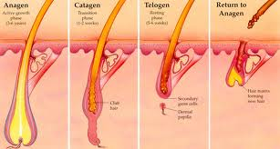
How many treatments will I need?
Because not all hairs are in the active stage during treatment, a series of treatments are necessary. The industry standard is a minimum of 6 treatments depending upon individual variables. Treatments are usually given at intervals of 6-8 weeks. Our clinicians can discuss your goals to develop a program based on your specific circumstance.

Sanctuary Laser Spa Sanctuary Salon & Med Spa
6900 Turkey Lake Road, Suite 1-5 6735 Conroy Road, Suite 104
Orlando, Florida 32819 Orlando, Florida 32835
407-909-1011 407-909-1011
www.sanctuarysalondayspa.com (10)

